EE3008A/B – Linear Systems and Signal Processing
Department of Electrical Engineering
The Hong Kong Polytechnic Unviersity

MATLAB Exercise for Hw 1
(Due date: Sunday Sept 21, 2025)

In this exercise, you will be using the MATLAB program to get a sense of how x(2t), x(t/2) and x(-t) “sound” like, if x(t) is a piece of music. Let’s get started:
- Download a music clip:
Pick any .mp3 files you like. You can also download a video clip and extract the audio component into an .mp3 file
- Load the music waveform into MATLAB
We make use of the MATLAB built-in function audioread( ) to load the music waveform.
[y, FS]= audioread(FILENAME)reads an audio file specified by the string FILENAME , returning the sampled data in y and the sample rate FS, in Hertz.
- Extract a 10s clip from the original music
As we have obtained Y, which is the sampled data of the music, we extract a piece of it (say, from 10s to 20s) out by defining a new array y_t=y(FS*10+1:FS*20);
Now you may want to see how the music’s waveform looks like, here we plot the first 0.01 s of the extracted 10s piece. Define the time vector as t=1/FS:1/FS:0.01; (a vector corresponding to the sample times [1/FS 2/FS 3/FS …..0.01] ). Then we use the plot( ) function.
plot(t,y_t(1:length(t))) plots vector y_t versus vector t.
You should get a sample waveform that looks like this. (but the duration of your waveform will be 0.01 as supposed to 0.001 in the following graph)
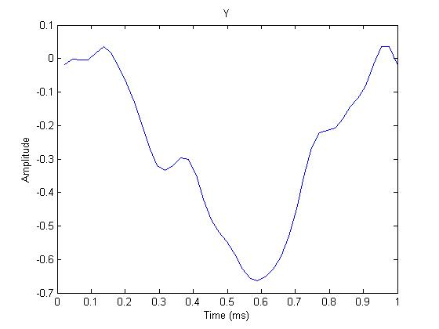
Save or screen capture your waveform and name it as “waveform.jpeg” when submitting.
- Half the speed of the music clip.
We could add ‘0’ in between every two sampled data to slow down the music by defining another vector y_slow
y_slow =[0 y_t(1) 0 y_t(2) 0 y_t(3) 0 …y_t(m-1) 0 y_t(m) 0]
where m is the original length of y_t. If we plot y_slow, we get the waveform on the left, be aware how adding ‘0’s to the vector has distorted the waveform.
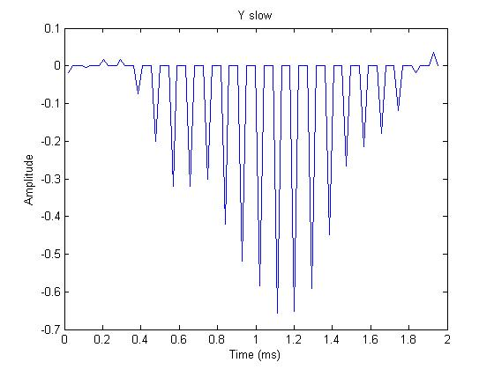
After adding ‘0’s
Before adding ‘0’s
Now we show you how such operation could be done. First, we can define a vector full of zeros that has double the length of the y_t

y_slow=zeros(1,2*length(y_t)) ;
You may use a for-loop to add content to the y_slow vector. (You should be able to write a simple for loop yourself. Please google if you are not 100% sure about the syntax. The task here is to make the samples y_slow(2)=y_t(1), y_slow(4)=y_t(2), y_slow(6)=y_t(3) etc ). In case your program runs into an infinite loop, you can press “Ctrl+ C” to terminate the program.
- To preview your music, write the following code:
player=audioplayer(y_slow,Fs);
play(player)
How does it sound?
- Export y_slow and save it as slow.mp4
We use the function audiowrite( ) to export the music.
audiowrite(‘slow.mp4’,y_slow,FS) writes data y_slow to an audio file slow.mp4, with a sample rate of FS Hz.
- Double the speed of the music
Staring from y_t, produce y(2t) by discarding every other sample. Now your waveform should be less smooth as shown in the left figure.
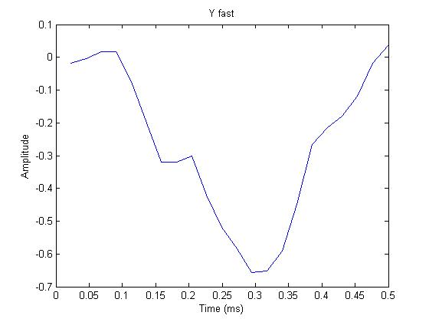
After discarding samples
Before discarding samples
The procedure will be very similar to the ones in generating y_slow. Let’s call it y_fast. You can first define y_fast as
y_fast=zeros(1,0.5*length(y_t)) ;
Again, write a for loop to produce the samples for y_fast . The task here is to make the samples y_fast(1)=y_t(2), y_fast(2)=y_t(4), y_fast(3)=y_t(6)etc.
- Play y_fast. How does it sound?
- Export y_fast and save it as fast.mp4
- Generate the backward version of the piece of music, i.e. y_back(t) = y(-t). Define

y_back=zeros(1,length(y_t)) ;

and write another for loop.

- Play y_back. How does it sound?
- Export y_back as backwards.mp4
Submission guidelines: Please put the codes and waveform figures in a single .pdf file for submission to Blackboard. Please also submit the generated .mp4 files
Remarks:
For more MATLAB guide:
https://www.mathworks.com/help/matlab/index.html
Some common MATLAB commands:
clc | Clears Command window
clear | Removes variable from memory
help | Searches for a help topic
For more MATLAB common commands, you may go to:
http://www.hkn.umn.edu/resources/files/matlab/MatlabCommands.pdf

